Daily Weather in the U.S., 2017 (NOAA)

Exploring national weather patterns and data quality

Introduction
I picked the 2017 U.S. Daily Weather dataset for this project. I wanted to see how the weather changed throughout the year and check if the massive amount of data (over 400,000 rows) was accurate or contained errors. By analyzing temperature, precipitation, and snowfall data, I aimed to better understand the overall structure of the dataset and identify interesting patterns or relationships between the weather variables.

Initial Questions
What is the overall distribution of daily temperatures in the dataset?
How common are precipitation and snowfall events?
Are there seasonal patterns in temperature throughout the year?
Is there a relationship between temperature and precipitation?
Which states contribute the most weather observations in the dataset?

Data Quality & Structure Exploration
Before diving into the visualizations, I performed an initial audit of the dataset to understand its shape and identify any potential issues.

Using df.info() and df.describe(), I found that the dataset contains 416,937 rows and several key weather variables. While the dataset is massive, it is not perfectly clean. I noticed that some columns, like wind direction (WDF5) and SNOW, have significantly fewer "counts" than the temperature columns, indicating a fair amount of missing data.

Initial Findings on Quality
Missing Values: I used df.isnull().sum() to locate "holes" in the data. Snowfall (SNOW) has the most missing data with 281,828 empty rows. This influenced my analysis by reminding me that "0" in the dataset might sometimes mean data wasn't recorded, rather than a lack of snow.

Extreme Outliers: The df.describe() results showed a minimum temperature of -147.82°F and a maximum of 261.68°F. These extreme values are a red flag for sensor errors, as they fall outside the range of survivable Earth temperatures.

Geographical Imbalance: By running value_counts() on the state column, I discovered that Utah (UT) is the most active state with 31,642 records, followed by Montana and California. This reveals a "Western Bias" in the structure of the data, which I kept in mind during my regional analysis.

Visualizations
The following visualizations explore these questions and provide insights into temperature trends, precipitation patterns, and the overall structure of the weather dataset.

Question 1: What is the overall distribution of daily temperatures in the dataset?
Analyzed through Visualizations 1, 2, and 3.

Visualization 1 (Max Temp): The x-axis has the maximum temperature recorded while the y-axis shows the frequency. This graph shows high frequency between about 40 and 100, which means that most days recorded maximum temperatures within that range. Very low and very high temperatures don't appear that much.
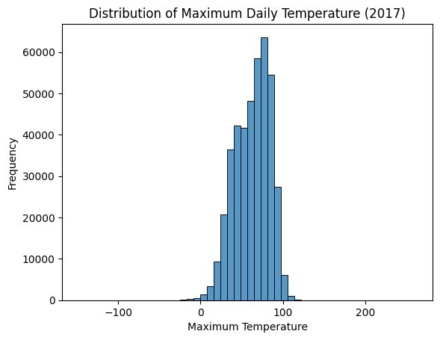

Visualization 2 (Min Temp): Most of these values cluster in a moderate middle range between 35 and 50 degrees. The smaller bars on the left show that very cold nights are not that common compared to typical cool nights.
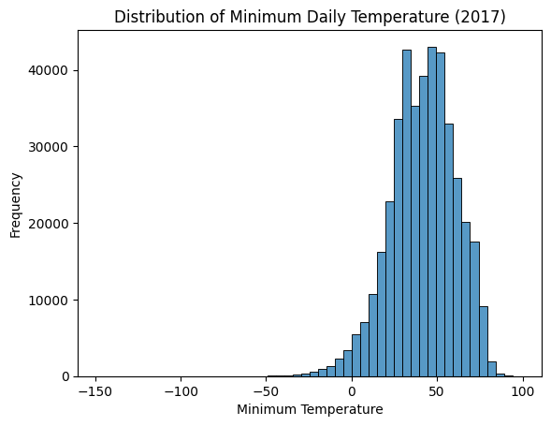

Visualization 3 (Outliers): The box in the middle shows where the bulk of the data falls, between 40 and 85. However, the points way out past the lines are outliers, reaching as high as 261.68. This answered my question by proving that while most temperatures are moderate, there are clearly "impossible" errors in the file.
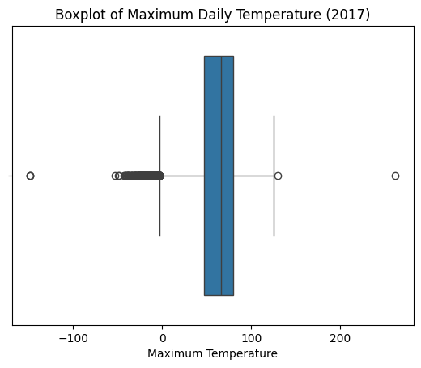

Question 2: How common are precipitation and snowfall events?
Analyzed through Visualizations 4 and 5.

Visualization 4 (Precipitation): Most data is shown toward the 0.00 rain, which represents dry days. Since the average rainfall is only 0.11, the bars in the graph drop off almost instantly, answering that rain events are relatively rare.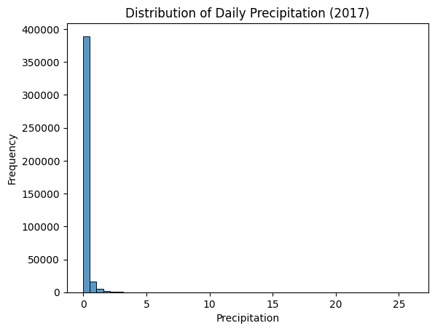

Visualization 5 (Snowfall): Same as the rain, almost all the data is at 0, which means most stations had no snow. This indicates that snow events occur even less frequently than rain in this dataset.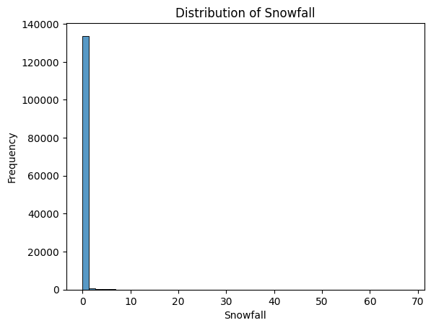

Question 3: Are there seasonal patterns in temperature throughout the year?
Analyzed through Visualizations 6, 7, 12, and 13.

Visualization 6 & 13 (Monthly Averages): These show a clear seasonal temperature pattern. The chart creates a "mountain shape" where temperatures gradually increase during the middle months and decrease later, peaking in the summer.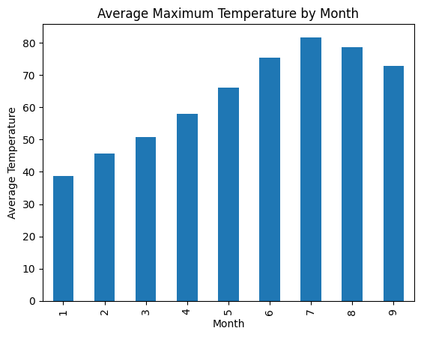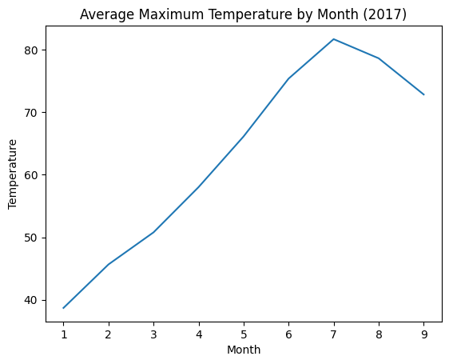

Visualization 7 (Monthly Rain): This showed that precipitation varies throughout the year rather than being even. For example, the bars for the first few months are higher, suggesting a "rainy season" early in the year.
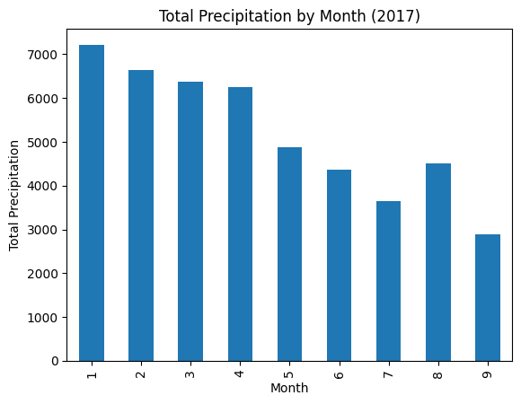
Visualization 12 (Daily Trend): This line chart reflects natural weather variability. The line goes up and down daily, but the overall "wave" over the 12 months confirms the seasonal cycle.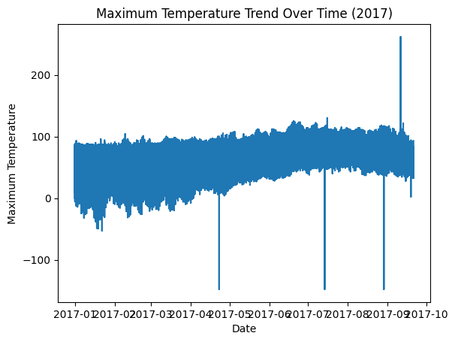

Question 4: Is there a relationship between temperature and precipitation?
Analyzed through Visualizations 8 and 11.
Visualization 8 (Scatter Plot): Because the dots are spread out, it shows that rain can happen at almost any temperature. However, the highest dots (heavy storms) mostly cluster between 60 and 100 degrees, showing the most intense rain usually happenson warmer days.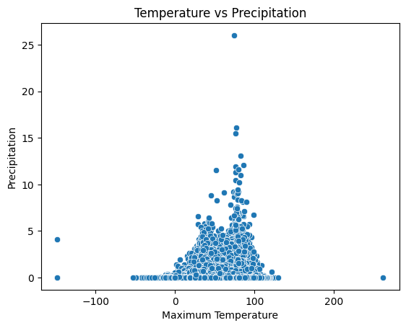

Visualization 11 (Heatmap): This answered the question by showing that TMAX and TMIN have a strong positive correlation (they move together), but precipitation and snowfall show weaker relationships with temperature.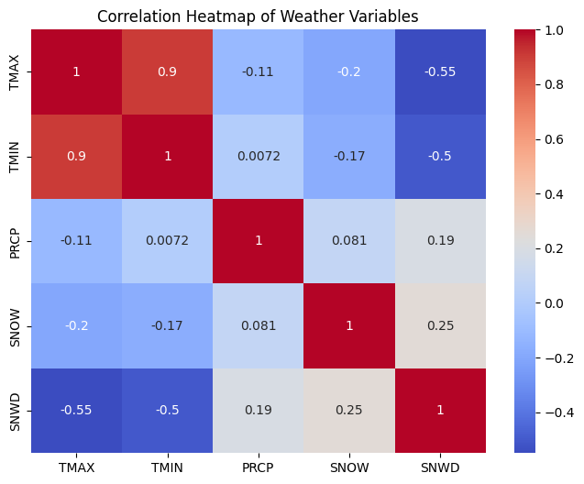

Question 5: Which states contribute the most weather observations in the dataset?
Analyzed through Visualizations 9 and 10.

Visualization 9 (Record Counts): This answered my question by showing Utah has the most records, followed by Montana and California. This suggests the dataset is heavily concentrated in the Western U.S.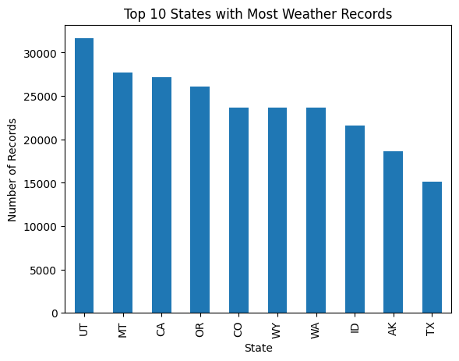

Visualization 10 (State Averages): This follow-up showed how climate varies by state. For example, Texas has a taller bar than LA (Louisiana), proving it stays warmer on average even within this western-heavy dataset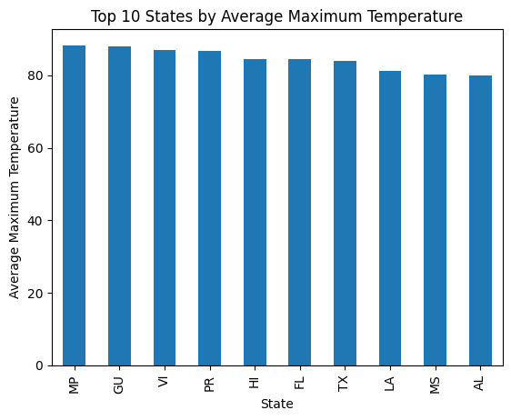

Follow-up Questions (Depth of Exploration)
Does the regional bias towards the West affect the "National" average?
When I saw in Visualization 9 that Utah, Montana, and California dominate the records, I wondered if the temperatures I was seeing were truly "National."

Ans: By creating Visualization 10, I was able to see the wide gap between states. Because the dataset is so Western-heavy, the "average" temperatures I calculated are likely cooler than a true U.S. average would be, since it includes so many high-altitude mountain records from Utah and Montana.

Data Transformation & Preparation
To dig into seasonal trends, I had to get the raw data into shape. I first took the date column which started out as just a string and turned it into a python datetime object. That let me break out details like the month for each record. I added a new column for month numbers (1–12), which made it easy to group everything by month. This step really opened the door to looking at averages and totals by month, instead of just getting lost in day to day details.

Summary of Main Lessons Learned
As I explored the 2017 U.S. weather data a few patterns jumped out. For starters, most of the maximum and minimum temperatures were in the moderate zone. Extreme highs and lows were kind of rare. But then when I checked the boxplots I spotted some wild values temperatures over 200°F. Clearly something went wrong there probably with a sensor or a data entry mistake.
The analysis also revealed a clear seasonal pattern. Temperatures followed a predictable wave throughout the year, gradually increasing toward the middle months and peaking in mid-summer before decreasing again later in the year. This confirms the expected seasonal cycle in weather patterns..
Something else I noticed was nighttime and daytime temperatures are tightly linked. When I ran the correlation analysis, it was obviousminimum and maximum temperatures tend to move together, while precipitation appears much more random and does not strongly follow temperature patterns..
The data isn’t evenly spread across the country. States like Utah and Montana had way more records than others, so the western states kind of dominate the dataset. Because of that the averages I calculated don’t paint a perfect picture of the whole country.
In the end this exploratory analysis helped reveal the structure of the dataset, identify seasonal trends, detect possible data quality issues, and uncover relationships between key weather variables.

